

Assignment – 1

* **Install Power BI Desktop and share the final screenshot of the report view page which appears when power desktop starts.**

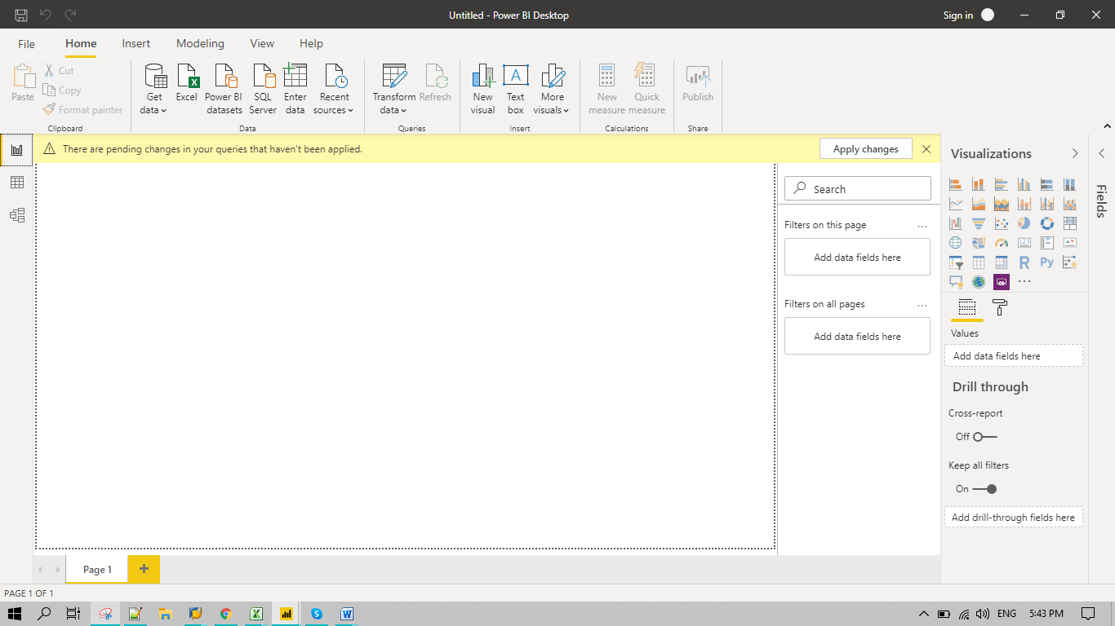

* **Prepare a document and with the following screenshot**
  + *Report View*

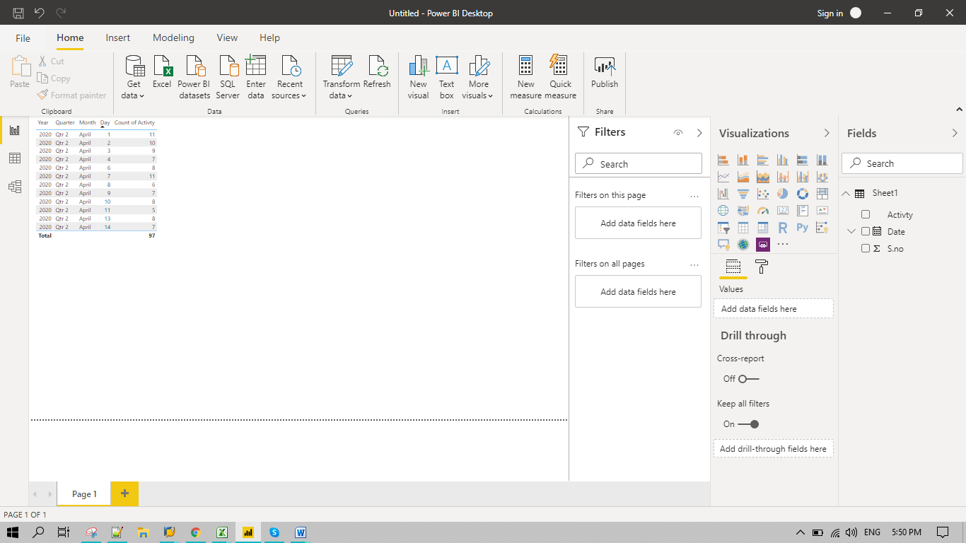

* + *Data View*

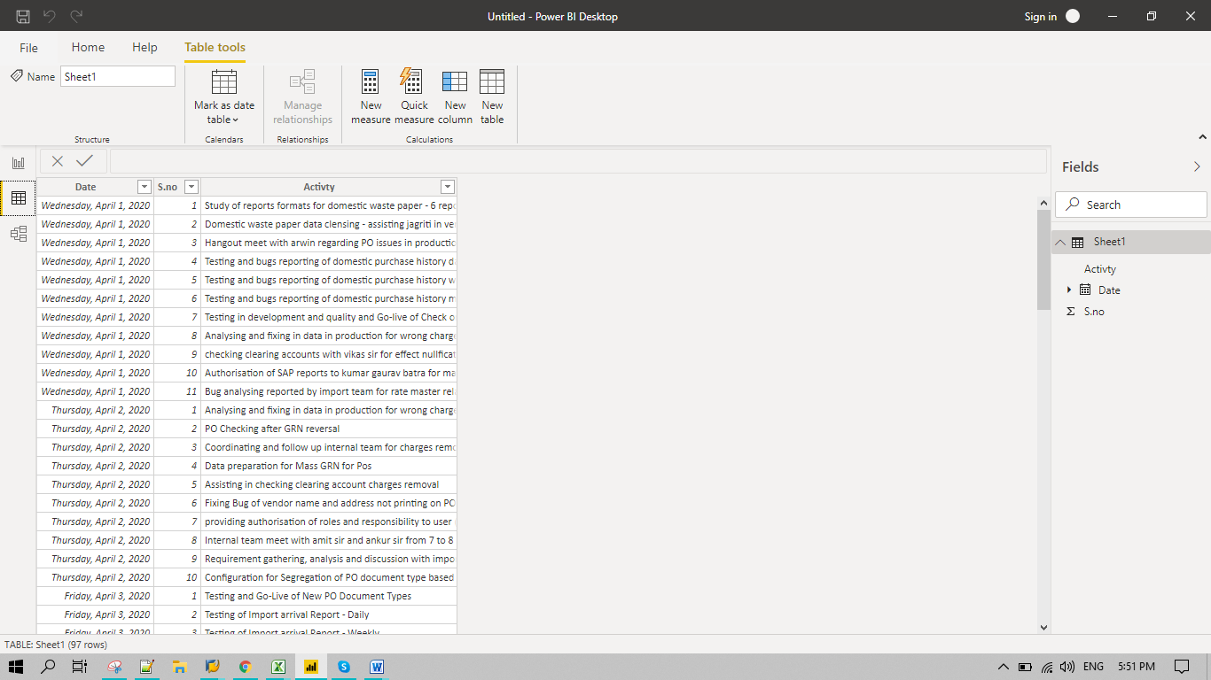

* + *Model View*

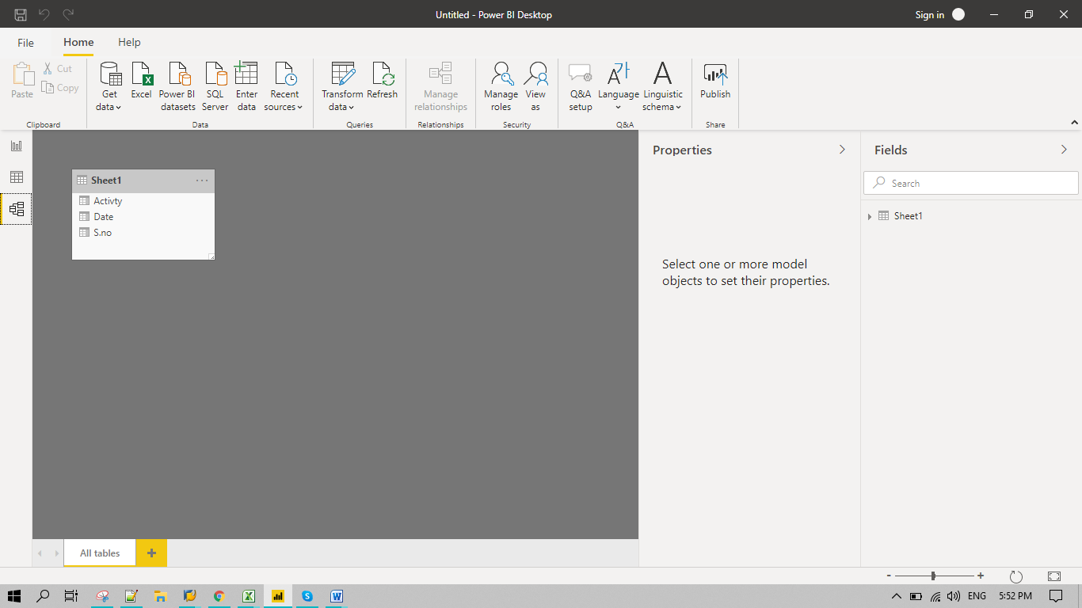

* + *Power Query Editor*

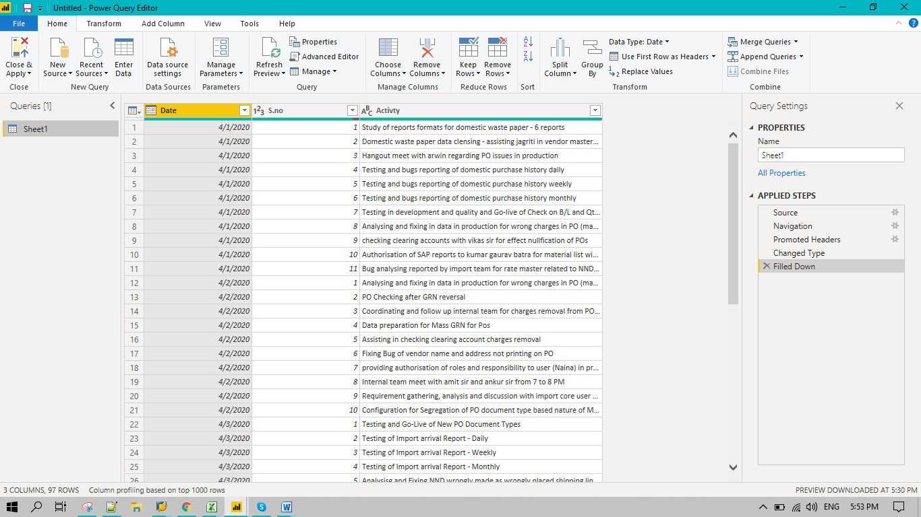

* + *Advance Editor*

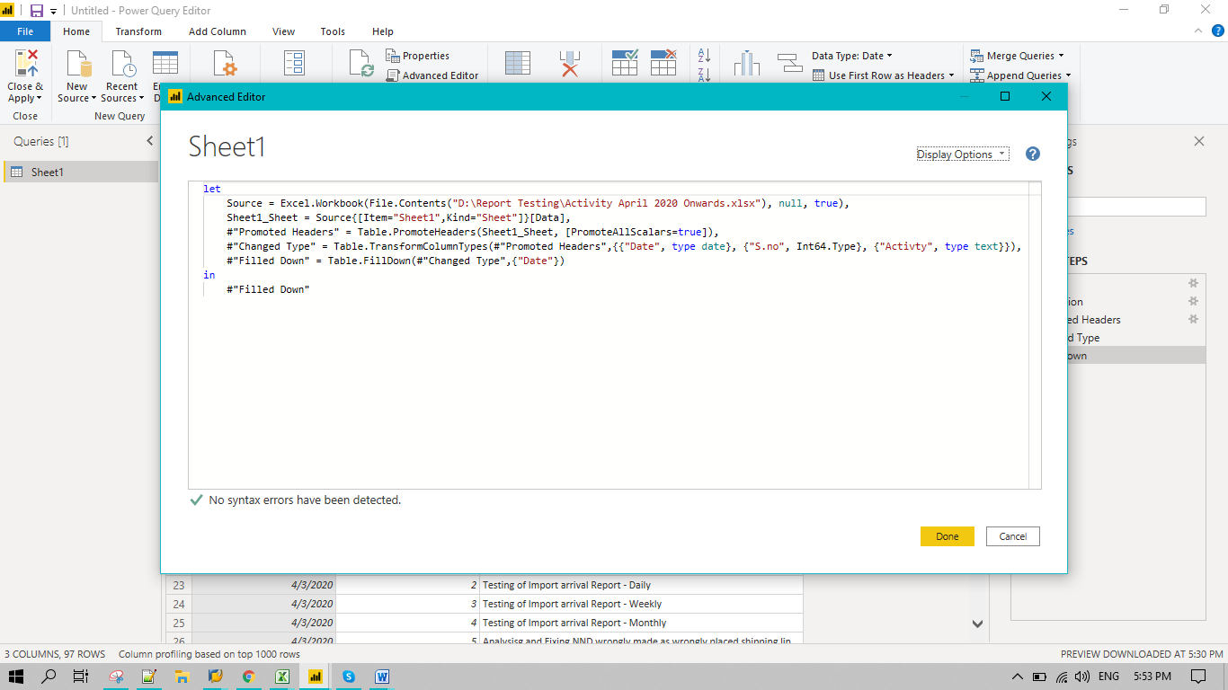

* **Prepare a document with details of the following along with their price**

|  |  |  |  |
| --- | --- | --- | --- |
| **Product** | **Additional Features** | **Price** | **UoM** |
| Power BI Desktop |  | Free |  |
| Power BI Pro | 1. Self-service and modern BI in the cloud 2. Collaboration, publishing, sharing, and ad-hoc analysis 3. Fully managed by Microsoft | $9.99 | Monthly Per User |
| Power BI Premium | 1. Enterprise BI, big data analytics, cloud and on-premises reporting 2. Advanced administration and deployment controls 3. Dedicated cloud compute and storage resources 4. Allows any user to consume Power BI content | $4,995 | Monthly plus cloud compute and Storage |